

Department | FED
Subject | DSA-2
Academic Year | Ⅰ-Ⅲ Semester(2025-26)
Faculty Name | Ms. Alluri Swathi
Student Name | Anumola Jhansi Priya
Roll Number | 2520090205
Branch | CSIT
Course Outcome | 2
Case Study Topic: SecureVote – Digital Voting & Election Analytics System using Segment Tree

Work Done Summary:
Implemented a Segment Tree in Java for secure election analytics and vote monitoring. Stored vote counts of candidates in the Segment Tree for efficient range-based vote analysis. Inserted multiple voting records and updated vote counts dynamically during ballot casting. Implemented range query operations to analyze votes between candidate ranges and election regions. Supported fast vote updates, fraud detection, and auditing operations using Segment Tree properties. Segment Tree provides efficient performance for election result analysis and real-time vote monitoring systems.

Implementation Details :
- Defined SegmentTree class with arrays: tree[], votes[] and integer n.
- buildTree() constructs the Segment Tree from initial vote counts.
- update() updates vote count dynamically when new votes are cast.
- rangeQuery(left, right) retrieves total votes within a given candidate range.
- Fraud detection performed by monitoring abnormal vote updates.
- Main method inserted vote counts, updated votes, and executed range queries.
- Segment Tree supports efficient analytics for large-scale election systems.

Result : Screenshots/Output
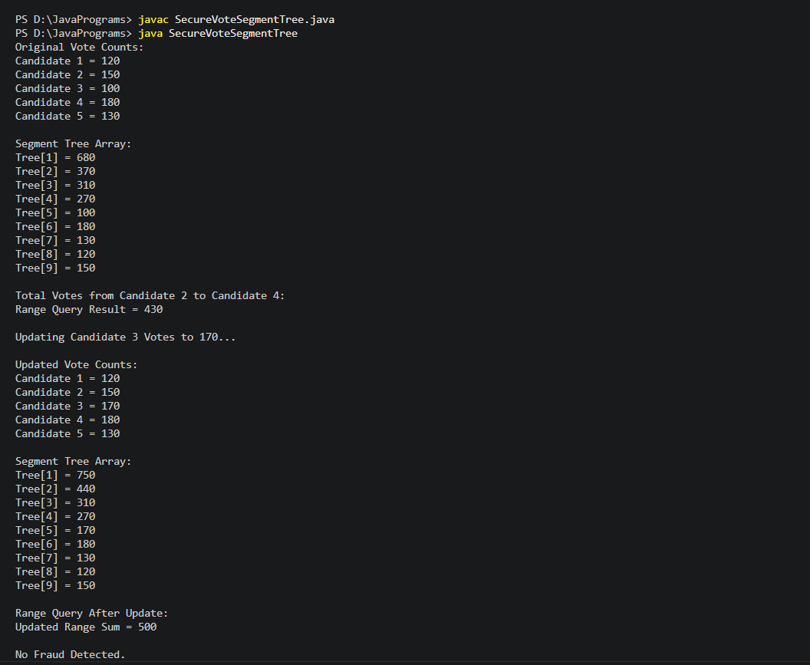

Time Complexity:
• Build Segment Tree: O(n)
• Update Operation: O(log n)
• Range Query: O(log n)
• Segment Tree is highly efficient for dynamic vote updates and election analytics.

GitHub Link :

Student Signature | Faculty Signature

